CRYSTAL GROWTH AND CHARACTERISATION OF Strontium ON THIOUREA
Dr.P.Girija, Professor, Departmemt of Chemistry.Annamalai University, Annamalai Nagar, Chidambaram, Tamilnadu, India.
Dr.P.Girija, Professor, Departmemt of Chemistry, Arignar Anna Government Arts College, Villupuram.

ABSTRACT
Thiourea, being a potential organic Non-linear optical material with
high SHG efficiency having application in laser technology and
photonic applications are grown as single crystals of Strontium
chloride doped thiourea by slow evaporation solution growth technique
(SEST), one of the best method for crystal growth at room temperature. It is
further analysed by single crystal XRD which infers that the Strontium
Chloride doped thiourea crystal has monoclinic system. The surface
morphology was studied by SEM-EDS, that confirms the presence of
Strontium in the doped specimen. FTIR reveals some slight variation in
vibrational frequencies and no secondary vibrational bands arefound in the
doped specimen indicating the presence of some dopant.

Keywords: SEST, SEM-EDS, Single crystal XRD, organic material.
Corresponding Author:
Dr.P.Girija, Professor, Departmemt of Chemistry.Annamalai University, Annamalai Nagar, Chidambaram, Tamilnadu, India.
Dr.P.Girija, Professor, Departmemt of Chemistry, Arignar Anna Government Arts College, Villupuram.
Email id: gk_au09@yahoo.com

Introduction
Non-linear optic (NLO) material showing second harmonic generation have been in demand over the last few decades due to technological importance in fields of optical communication single processing and instrumentation^{[1]}.Recently thiourea has got a wide application in the production of crystal analyserfor long wave X-ray spectrometer. Being a good non-linear optical material, thiourea possess piezoelectric, pyroelectric and elastic properties^{[2]}. The NLOproperties of metal complexes of thiourea have attracted singnificant attention in the last few years, because both inorganicand organic components contribute specifically to the process of SHG. Metal-organic complexes offer higher environment stability combined with greater diversity of tunable electronic properties by virture of the co-ordinated metal center. Many metal thiourea complexes possessing second-order NLO avtivities^{[3]} and some of them centosymmetric in nature have been reported^{[4]}.Thiourea crystals attract the attraction of boththeoreticians and experiments due to the non-linear optical Piezoelectric properties .Thiourea possesses a large dipolemoment which are potentially useful material for frequency doubling of near IR laserradiation.It is also significant impact on laser technology, optical communications and optical data storage^{[5-10]}. In the development of science in many areas has been achieved through the growth of thiourea crystals.Non-linearoptical (NLO) Materials are expected to play a major role in thetechnology of photonic including optical information processing .Many research efforts are undertaken to synthesize and characterize new molecules for secondorder non-linear optical (NLO) applications such as high speed processing, Telecommunications, Remote sensing laser, and optical data storage ^{[11-16]}. Recently the effect of organic additives Mn(II), Ce(IV),Cs(I)and Mg(I),(N₂H₄CO),(N₂ H₄CS). Organic solvent on ZTS and enhancement of SHG efficiency of thiourea on picriacid^{[17]}. Thiourea is an interesting inorganic matrix modifier due to its large dipole moment^{[18]}and its ability to form an extensive network of hydrogen bond It belongs to the orthorhombic crystal system. Only a few of thiourea complexes viz, Zinc thioureasulphate^{[19,20]},Cadmium thioureaacetate^{[21]}, bisthiourea cadmium chloride. The search for new and efficient NLOmaterials has resulted in the development of a new class of materials called organic mixed crystals. In this paper Strontiumchloridethiourea single crystal is synthesized and grown by slow evaporation technique at room temperature. The effect 0f doping is studied using single crystal XRD, Fourier Transformation Infra Red Spectroscopy, and SEM-EDS.
Experimental Details
Crystals were grown by slow evaporation solution growth technique. Doping of Strontium Chloride (equimolar) to Thiourea is done during the crystallization process. The crystallization process took place around 17-23 days and the transparent macroscopic defect free crystals are harvested. The photographs of Strontiumchloride doped TU crystals are shown in figure 1. Bulk crystals are grown using optimized growth parameters.
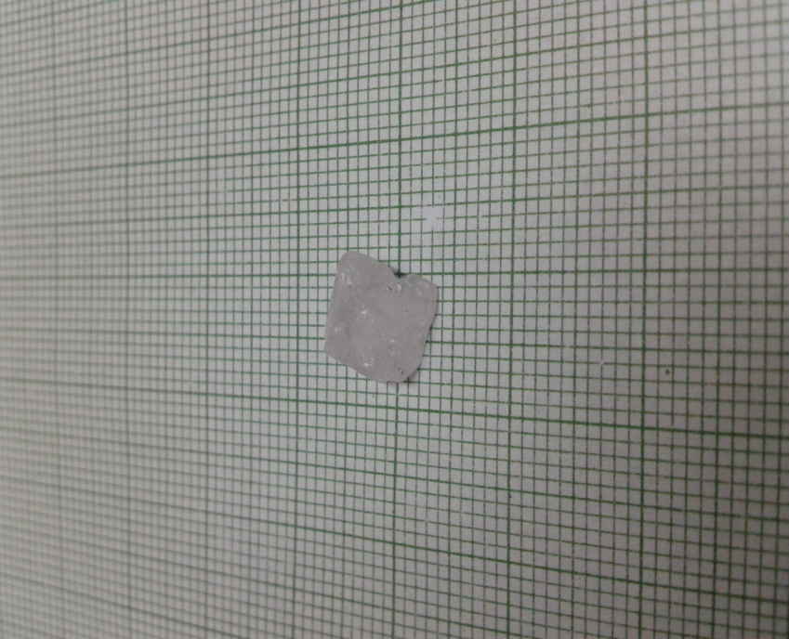

Fig.1. Images of Sr doped Thiourea crystal

RESULTS AND DISCUSSION
SCANNING ELECTRON MICROSCOPY (SEM) WITH ENERGY DISPERSIVE X-RAY SPECTROSCOPY (EDS)
The surface morphology was observed using a JEOL JSM 5610 LV
Scanning electron microscope which has a resolution of 3.0nm and an
acceleration voltage of 0.3 to having the maximum magnification of 2,00,000
times. EDS is a chemical microanalysis technique performed in conjucation
with a SEM. The EDS X-ray detector measured the number of emitted X-ray
photons and their energy. [SEM study JEOL JSM 5610lv] gives information
about the surface nature and its suitability for device fabrication, also used
to check the presence of imperfections. The effectiveness of different
impurities in changing the surface morphology is different has been
reported¹⁷.
Figure 2. shows the scanning electron micrographs recorded for
Strontium undoped Thiourea crystals. The micrograph depicts the
surface features of the doped specimen and shows a resonably good
uniform surface with some roughness which could be due to impurities, the
(Seleniumdioxide doped TU) specimen and shows cauliflower like
appearance with some bubble voids which could be quite likely due to the
evaporation of solvent from the crystal surface.

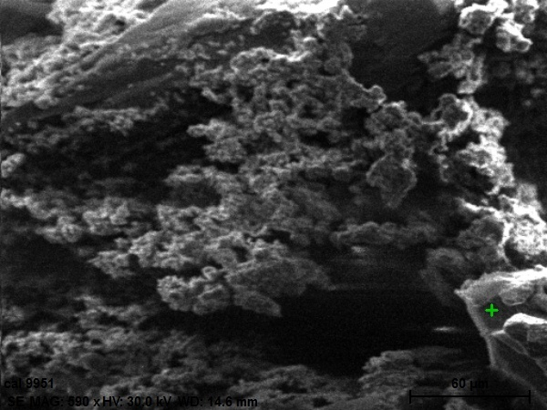
Fig 2 SEM graph of Strontium doped TU

The doping of Strontium resulting in its incorporation into the crystalline
matrix is well confirmed by EDS figure 3. The higher concentration of
Strontium into the Thiourea crystalline matrix can be clearly seen in the
graph. The accommodating cabability of Selenium on the surface of the
crystal in also non-uniform.

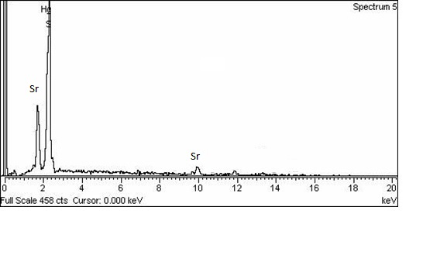
Fig3 EDS graph of Sr doped TU crystal

SINGLE CRYSTAL X-RAY DIFFRACTION :
Single crystal X-ray diffraction studies were carried out using Bruker AXS
(Kappa APEX II) X-ray diffractometer. Data were collected on a diffraction
system, which employs graphite mono chromated Mo Kα radiation
(λ = 0.71073Å).The table -1 shows the cell parameter values for pure
Thiourea and Strontium doped thiourea crystals. The pure thiourea crystal
belongs to orthorhombic system with a =7.660A⁰, b=8.54A⁰, c=5.52A⁰, and
space group Pca21. The lattice constants for Strontium doped thiourea,
obtained by cell refinement with least square fitting of the lines in range of
20⁰≤20≤120⁰ are a=6.21A⁰, b=12.61A⁰, c=9.31A⁰ with monoclinic
system, v=697A⁰³ and α=90⁰, β =106.98⁰, γ=90⁰ . Here the changes in the
cell parameter values of doped specimen compared to pure one could be
due to higher concentration of doping effect leading to structural changes by
substituting strontium in the place of ‘S’ in thiourea.

Table 1–The cell parameter values of thiourea and Sr doped TU crystal

Lattice Parameter Values  Thiourea  Thiourea/  Strontium | a  A⁰  7.66  6.21 | b  A⁰  8.54  12.61 | C  A⁰  5.52  9.31 | v  A⁰³  176  697 | System  Orthorhombic  monoclinic

FOURIER TRANSFORM INFRARED SPECTROSCOPY (FTIR)
Fourier transform infrared spectroscopy (FTIR) studies were carried out on the grown crystals in order to understand the structure and bonding in them. FTIR spectra are recorded for pure and doped thiourea crystals by using AVATAR 330 FT-IR instrument by KBr pellet technique in the range 400-4000cm⁻¹ the figure .4 shows the FTIR spectra of thiourea and Strontium doped thiourea crystal investigating the presence of functional groups and their vibrational modes, between the frequencies 400 and 4000cm^{-1.}The shifts in vibrational frequencies of doped specimen compared to pure thiourea are tabulated as follows. Comparison of characteristic frequencies of thiourea and Strontium doped thiourea crystal is shown in table-2
Table -2: comparision of vibrational frequencies of pure and Selenium doped thiourea crystal

Wavelength of thiourea cm⁻¹ | Wavelength of Se|Thiourea cm⁻¹ | Tentative assignment
3395 | 3406.29 | γ_{as}(NH₂)
3179 | 3170.97 | γ_{s}(NH)
2674 | 2682.98 | γ_{s}(NH₂
2104 | 2347.37 | γ (NCN),NH₃⁺
1500 | 1612.49 | δ(NH₂)
1464 | 1473.62 | γ_{as(CN)}
1395 | 1404.18 | γ_{as(C=S)}
1089 | 1224.80, 1078.21 | γ_{s(CN)}
729 | 727.16 | γ_{s}(C=S)
485 | 503.42 | δ_{as(NCN)}

In the above table a very slight shifts in some of the characteristicvibrational frequencies of pure thiourea is observed because of doping of Strontium which could be due to lattice strain developed.Here the wave number γ_{as} NH₂ absorption bands in thiourea 3395cm⁻¹ was shifted to lower wavenumbers 3406.29cm⁻¹ in Strontium doped thiourea crystal, the broadening of the band in doped one at 1224.80cm⁻¹ on comparing to pure thiourea infers that there are no strong hydrogen bonding in the doped specimen instead there is much weaker tendency to form hydrogen bonding. The bonding vibration(δ_{as}NH₂,γ_{C=S)} thiourea at1621 and 1395cm⁻¹ is shifted to 1612.49cm¹and1473.62 and 1404.18cm⁻¹in doped specimen indicating the formation of Strontiumthiourea single crystal.

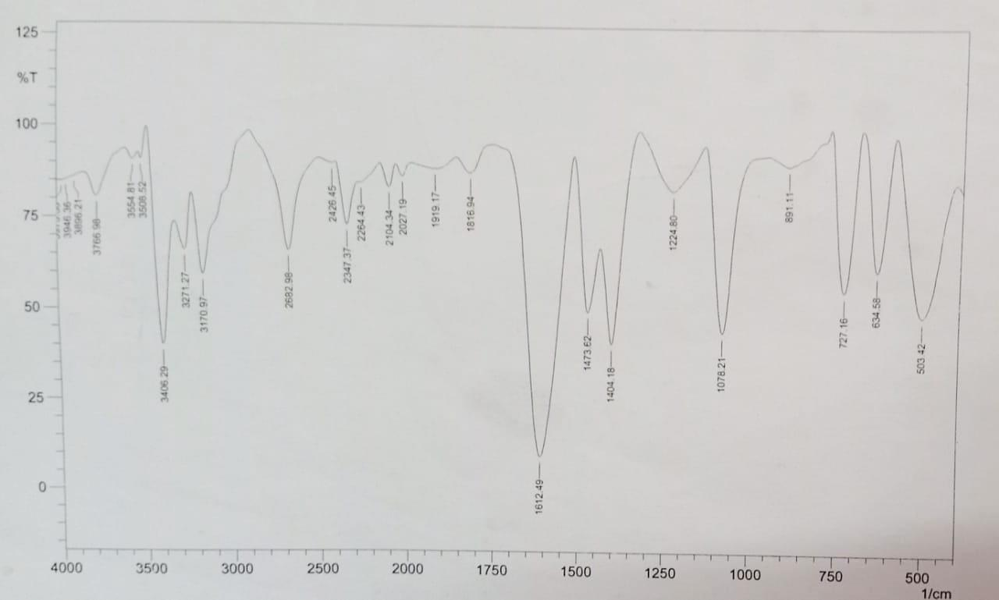
Fig.4 FTIR Spectra of Strontium doped TU Crystals

CONCLUSION
Using single crystal XRD, FT-IR and SEM-EDS techniques, the effect of Strontium doping on thiourea crystals has been investigated in our present
study. The surface morphology of the crystal was studied from SEM that
shows cauliflower like appearance with some bubble voids which could be
quite likely due to theevaporation of solvent from the crystal surface.and EDS Confirms the presence of Stontium in the doped specimen and a
slight variation in the intensity of the doped compared to pure TU specimen
due to doping effect. Heavy doping of Strontium on thiourea exhibits
increased vibrational peaks in FT-IR spectrum compared to pure TU.

REFERENCE

1.Qui J &LanL,MaterSci B, 133 (2006) 191.
2. C. Ramanchandraraja, R.S. Sundararajan and V. Krishnakumar, Spectrochim. Acta, Part A, 2009, 71, 1634.

3. K. Ambujam, P.C. Thomas, S. Aruna, D. PremAnand and P. Sagayaraj, Crys. Res. Technol., 2006, 41, 1082.

4. S.G. Bhat and S.M. Dharmaprakash, J. Cryst. Growth, 1997, 181, 390.
146.

5.Madhurambal,M.Mariappan,Indian J Pure &ApplPhys,48, (2010) 264.
6.G.Madhurambal,M.Mariappan,SCMojumdar, J Therm Anal calorim.100 (2010)853.
7.RavindranB,G.Madhurambal,M.Mariappan,scMojumdar,J Therm Anal calorim .104,(2011) 893.
8.S.Malyajdas, R.Prasad, Psen,Indian J Pure &ApplPhys .44(2006) 555.
9.B.Ravindram,G.Madhurambal,M.Mariappan,scMojumdar,JTherm Anal calorim .104,(2011) 909.
10.M.Mariappan, G.Madhurambal,B.Ravindran,Sc.Mojumdar, J Therm Anal calorim,104,(2011)915
11.S.Waghuley,SM.Yenorkar,SSYawale, S.P.Yawale,Sen, Actuators B,128 (2008)366.
12.J.Saima,Gruokova A, M.Papanova,J Elect Eng,56 (2005) 461.
13.A.Jayarama,S.M.Dharmaprakash,Indian J Pure &Appl Phys.44 (2006) 461.
14.K.Ogura,H.Shiigi,Electrochem.Solid state Lett., 2 (1999) 478.
15.J.Maier, M.Holziger,Sitte W, solid state Ionics, 74 (1994) 5.
16.A .Marotta,A.Buri,Thermochim,Acta,25 (1978) 155.
17.Y.Okaya,Actacrystallogr, 1965, 19,879.
18.Rams,J.Magnmagn matter, 80 (1989) 241.
19.SingP,Babbar V K, RazdonA,Goel TC and SrivastsavaSI,Indian
J ApplPhys, 42(2004)221.
20.Wuyouf and HaibinV.Wichsnunitech mater sci Edi, 21 (2006)
21.An SY, Lee S.W,Shin I and Kim CS, Magnetics (I EEE Transaction ), 37 (2001) 25 86.

